|  |  |  |  |  |  |
| --- | --- | --- | --- | --- | --- |
| Date | 6-Dec-22 | | | Tester Name | Richard Belanger |
| Environment | Penfax - Test | | | Login used | TEST2 |
| Operating System | Windows | Version: | Update: | | |
| Software Used | Edge | Version: | Update: | | |
| Not Applicable | Version: | Update: | | |
| Release version | 22.4.1 | | | | |
| Title | M12.05 Death of General casual member | | | | |
| Test Type | Regression | | | | |
| Test Scenario | Member will have Death calculation processed | | | | |
|  |  | | | | |
| Expected Results | Beneficiary will receive the benefit payment | | | | |
| Pass/Fail | Pass | | | JIRA# | N/A |

Describe your steps with screenshots:

Member terminated due to death

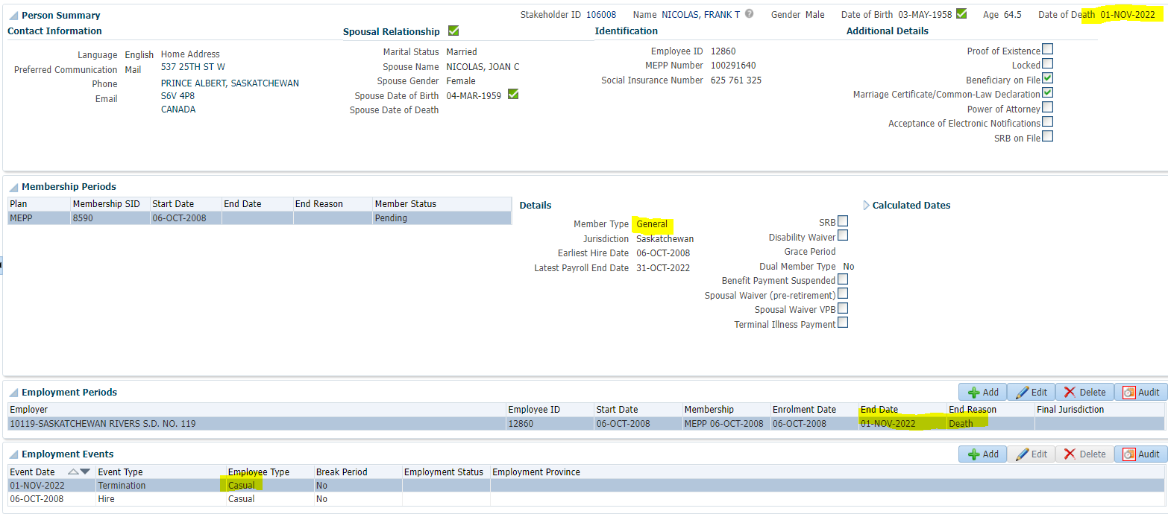

To Benefit Calculation>Calculate

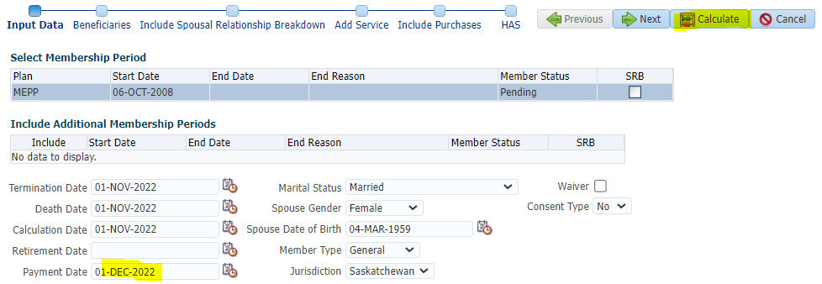

Processed

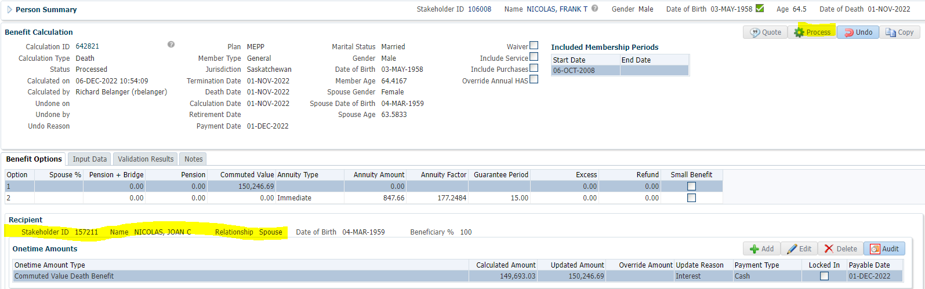

To Benefit Selection>Next

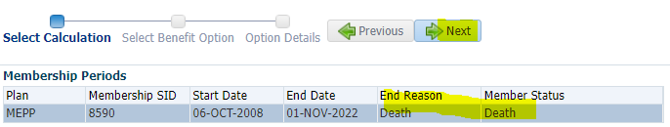

Choose Option add payment date>Next

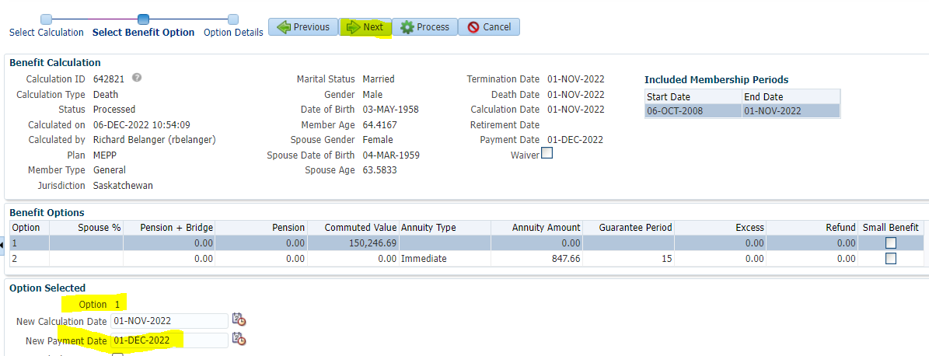

Add Payment Instructions>Process

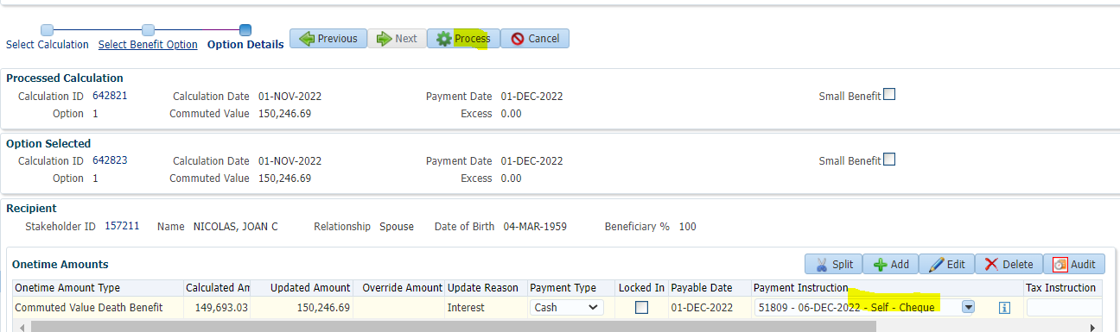

Processed>To Beneficiary (Spouse)>Benefit Recipient>Onetime Amounts

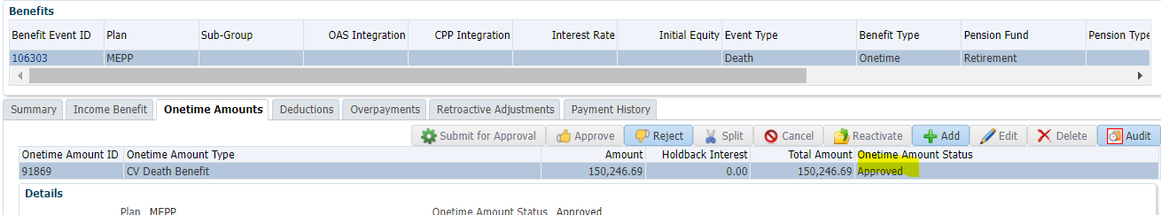

To Summary>Authorize

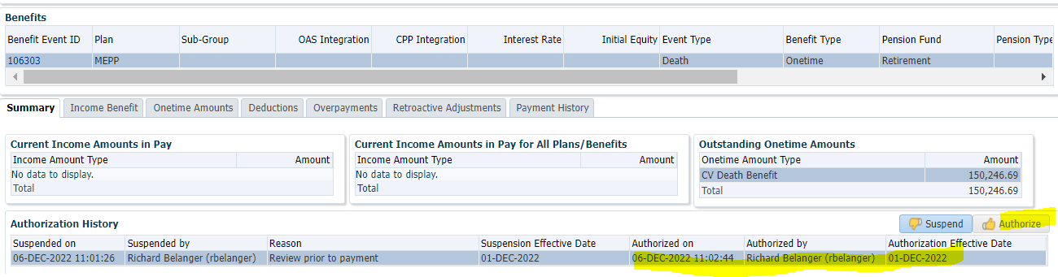

Payment Batch to run to see payments made

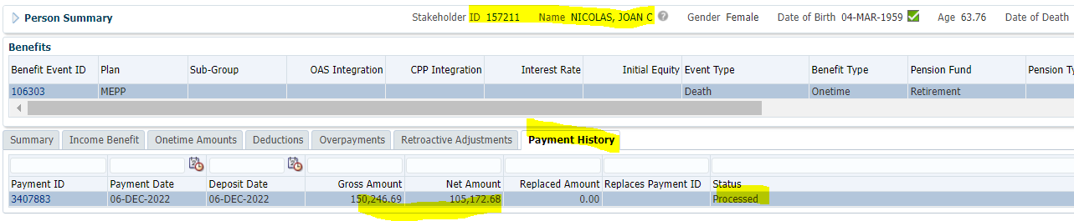

Tax Rates

0.00-4,999.99 = 10%

5,000.00- 14,999.99 = 20%

15,000.00+ = 30%

150,246.69 * 30% = $45,074.01; 150,246.69 - 45,074.01 = **$105,172.68**